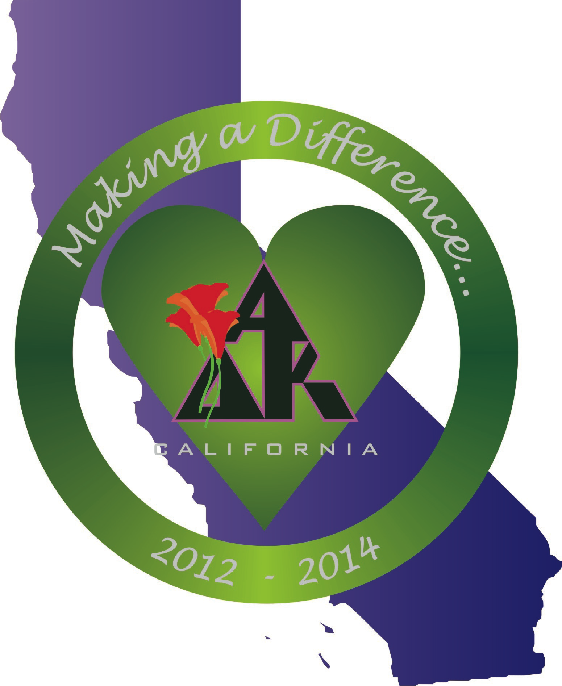
California Alpha Delta Kappa
Executive Board Meeting
March 9, 2013
Hacienda Hotel, San Diego, California

1.0 Call to Order: California State President Mollie Acosta called the meeting to order at 2:28 P.M.

2.0 Opening Thought: Rebecca read the opening thought “Authentic Success” from Simple Abundance by Sarah Ban Breathnach. Authentic success is different for each of us. It knows that if today were your last day on Earth, you could leave without regret. The best you can do is always enough. It is living each day with a heart overflowing.

3.0 Roll Call:
Members Present:
Mollie Acosta President
Susan Raffo Immediate Past President
Mary Ann Englehart President-elect
Kerry Hackman Vice-President
Diana Galvan Treasurer
Karen Kirby Recording Secretary
Lynne Keating Corresponding Secretary
Monica Meade Historian/Sgt-at-Arms
Rebecca Sikes Chaplain

4.0 Approval of Agenda:
Mollie proposed an addition to the minutes: 9.2.1 Update policies regarding baggage/airlines fees.
MOTION: Mary Ann moved we approve the agenda as amended, with 9.2.1 added. Susan seconded the motion. Motion passed.

5.0 Approval of Minutes:
MOTION: Susan moved we approve the minutes of January 12, 2013 as read. Rebecca seconded. Motion passed.

6.0 Correspondence: Lynne read the text of all sent and received correspondence.
6.1 Sent:
* Lynne sent a thank you to Barbara Murray for hosting the Marina District Conference.
* Mollie sent an email to Lei’ala Montoya giving her the names of the three state board members who will be attending the meeting on February 16, 2013.
* Karen Kirby sent a thank you to Nancy Parsons and her Pi sisters for inviting her to their fundraiser on February 7, 2013.

6.2 Received:
* An email was received from Lei’ala Montoya, former Gamma Rho member,
outlining arrangements for the February 16, 2013 meeting regarding the Coachella Valley chapter.
* An email was received from Lei’ala Montoya acknowledging the names of the state board attending the February 16 meeting.
* An email was received from Barbara Stanfield, SW IVP, acknowledging the arrangements of the February 16 meeting.
* An invitation to attend Alpha Nu’s fundraiser was received from that chapter’s Corresponding Secretary La Verne Stroetker.
* A thank you note was received from Linda Futterer, Gamma Eta, thanking California A∆K for the mini scholarship she received.
* A letter and personal $100.00 donation to the California Mini Scholarship fund was received from Carolyn Rising, Alpha Nu, California State Scholarship Chairman.

7.0 Budget/Expenses
7.1 Treasurer’s Report: Dues have been received from all chapters. The entire dues from one chapter were one week late. That chapter sent in $115.00 in late fees. We lost money due to resignations and sisters joining the Omega chapter. Dianna reminded the Board 1,240 sisters are dues paying members. We should use this information when creating the budget for the next biennium. Mary Ann suggested we include a section in the Footnotes for the budget describing the reasons the budget is less than before: a decrease in dues paying members. Mollie said she would like to see the budget posted on the website.

Dianna informed us the virus protection expires this week on the CAA∆K computer she uses. She will check on the computer’s paperwork for the virus protection password. She will also see if she can provide virus protection for free under her personal plan.

7. 2 Budget and Balances: The Working Budget spreadsheet and the Account Balances sheet were distributed. The Account Balance sheet reflects the current balances in the CA A∆K bank accounts and investment accounts.

The Wells Fargo accounts and balances as of 3/7/2013 are:

Checking Account $30,364.65
Reserve Account $45,872.91
Scholarship Account $13,592.15

Total Bank Accounts $89,829.71

Noel Leonard Foundation $40,363.42
Overall total $130,193.13

State Convention Account $10,601.63

7.2.1 Consider adjustment to Liaison reimbursements: Mollie raised the question should all liaison expenses be reimbursed instead of current policy, which allows reimbursement for only one meeting per year of the biennium. Diana reminded us that current Policies and Procedures say liaisons may not be reimbursed for one’s own council meeting. Discussion followed. It was acknowledged that reimbursement is allowed only when attending a council meeting as a California State Board member and the role of liaison in attending a council meeting is as a California State Board member, not as a council member.

MOTION: Diana moved the California State Board members shall be reimbursed for mileage, parking, and tolls for representing the State Executive Board at any council meeting. Monica seconded. Diana made an amendment to the motion. She moved that in the instance when more than one board member is assigned to a council as liaison, only one of those board members will be reimbursed. Kerry seconded. The amendment passed. The motion passed.

Susan will write a new Policy and Procedure for liaison reimbursements.

7.3 Reimbursements: All expense reimbursements and the Board circulated bills with receipts for the Southern District Conference for review.

7.4 MOTION to Pay Bills: Diana moved to pay the bills submitted as corrected. Monica seconded. Motion passed.

8.0 Unfinished Business:
8.1 Presidents’ Council Handbook Updates: Mary Ann received handbook updates from Susan. The website has not been updated yet, but will be updated soon.

8.2 Membership Report: Kerry reported CA-A∆K has a total of 52 chapters. Rho chapter has lapsed. Some Rho sisters will be joining other chapters. Other chapter membership concerns were discussed. Currently there are 1,354 members. 2 members have been reinstated. No one has transferred during this period. There are 32 sustaining members. There are 15 new members and 51 resignations since the last meeting. 11 members have gone to the Omega Chapter since May, 2012.

Kerry contacted all chapters who lost 2 or more members to see if there was anything the Board could do to assist chapters in retaining members. Karen suggested Kerry send all chapter presidents the pages from the Members Handbook that contains suggestions on member retention.

8.2.1 February 16, 2013 Meeting Report: The Executive Board reviewed Lynn’s comprehensive report of the meeting with former Gamma Rho sisters in Indio. The report listed the attendees: Former Gamma Rho sisters Eileen Chavez and Regina Van Wey; International Vice President, SWR, Barbara Stanfield; Connie Ko, Shirley Yamada, Judy Ching, Phyllis Takeuchi, Lei’ala Montoya, Ethel Murakami, Carol Nohara and Harriet Carmody from Hawaii chapters on Oahu; California State Executive Board members Mary Ann Englehart, Susan Raffo, and Lynne Keating; Guests Diosa Montes and Maria Hassan. The report described the opening thoughts by Eileen Chavez. In the report, Southwestern Region International Vice President Barbara Stanfield described the history, purposes, and mission of A∆K. She shared information about International project, and then outlined factors to consider when forming a new chapter. California State President-Elect Mary Ann Englehart and California Immediate Past President Susan Raffo provided information about the organization of A∆K in California with specific information about the newest members. Regina Van Wey shared a flier she created that provided information about Alpha Delta Kappa. At the conclusion of the meeting, Eileen Chavez provided a closing message, thanked all for attending, and for their support and dedication, and praised the teacher guests in attendance.

8.2.2 Membership Campaign: Kerry asked the Executive Board for membership campaign ideas. Ideas included recognition of chapters with new members at each district conference and a perpetual plaque to be awarded at each State Convention to the chapter with the highest membership net growth during the next biennium.

MOTION: Susan moved the Executive Board create a perpetual award honoring chapter positive net growth during a biennium as of March 15 in even years of the biennium. A plaque will be purchased and presented at the State Convention. Monica seconded. Motion passed.

Specific criteria will be needed for determining the recipient chapter. Diana suggested using the 7 Pearl criteria. Susan will write a policy for governing the plaque.

8.3 2010 – 2012 State Standing Committee Chairmen Recommendations: Policies and Procedures states that the Executive Board review suggestions after State Convention. The Board reviewed recommendations from the following chairmen:

8.3.1 State Bylaws Chairman Lora Ginsberg:
1. Continue to use a simple sign off for certification for those chapters who were certified in the 2010 – 2012 biennium. BOARD DISCUSSION: Accepted and ongoing.
2. Continue to assist chapters with understanding bylaws versus Policies and Procedures. BOARD DISCUSSION: Accepted and ongoing.
3. Continue with post card certification. BOARD DISCUSSION: Accepted and ongoing.

8.3.2 State Candidate Qualifications Chairman Pam Burris:
1. On the application have a location for e-mail address. BOARD DISCUSSION: Accepted and changes will be made.
2. On previous grid sheets a separate category was listed: Present teaching position. I think it is important to know if a candidate is retired or presently teaching. BOARD DISCUSSION: Accepted and changes will be made.

8.3.3 State Excellence in Education Chairman Karen Kirby:
1. In addition to the state newsletter, the chair should send an article via email to all California members with the nomination form attached. BOARD DISCUSSION: Accepted and will be put in place.
2. The nomination due date form could be moved to an earlier date, perhaps at the end of the first year of the biennium or the beginning of the second year. BOARD DISCUSSION: Recommendation is supported and Mollie will communicate suggestions and concerns at the International Convention.
3. Information and a nomination form could be included in the annual presidents’ package sent from International Headquarters. Information could be included in the Kappan. BOARD DISCUSSION: Recommendation is supported and Mollie will communicate suggestions and concerns at the International Convention.

8.3.4 State Resolutions Chairman Tara Stevens: Tara reported what happened but did not make any recommendations.

8.3.5 State Webmaster Janet Armstrong:
1. I recommend that California Alpha Delta Kappa switch their service to a provider that uses web-based software for site creation. Once the Webmaster sets up the site, the state president (and others she designates) will have the autonomy to make changes without going through the Webmaster. This will improve the efficiency of posting timely corrections. BOARD DISCUSSION: Accepted and this is being done.

8.3.6 State Communications Chairman Carole Taylor:
1. That an email database be established to include all the California state members. BOARD DISCUSSION: Accepted and Mollie will develop the database.

8.3.7 Implications of Policy/Procedure and/or Officer Duties: Susan has made notes while reviewing policies and procedures. Job descriptions will be revised as they correlate with certain policies and procedures.

8.4 California World Understanding Committee:
Susan contacted International Headquarters to see what International and other states had created as the job description for this committee chairperson. She received a job description from International, but to date no other state has submitted a job description. Kathleen O’Malley has agreed to chair the committee. We can use International as a base, and then solicit input to establish a California State World Understanding job description and a philosophy statement regarding a broader vision for world understanding in California. Mollie asked members to think about a new name for World Understanding.

8.5 A∆K Shirts Update: Diana brought completed shirts for review. We all decided we did not like the color. Diana will contact the company to see if they will accept return of the shirts and return our payment. Board members may opt to keep the shirt already paid for and apply any balance to the new shirt, or opt to have a new shirt only. Diana will see if members of her chapter will buy any unwanted shirts. We will continue to explore a new shirt in the appropriate A∆K violet color.

8.6 CA Logo Pins: Susan showed pictures of proposed pin designs. We discussed color, size, and design. The design with the multiple poppies in the center of California was chosen in a 1-¼ inch size with a few suggested changes.

MOTION: Diana moved we purchase 500 pins at $1.17 each plus tax. Mary Ann seconded. Motion passed.

Lynn will send thank you notes to Ophelia and Kelly for their work on the design.

8.7 International Convention, Washington DC, 2013:

8.7.1 Travel/housing plans: Individual plans were discussed. As per Policies and Procedures, housing, direct transportation to and from the convention, parking, tolls, and tips will be reimbursed from the CA-A∆K budget. Registration fees, meals, personal services, and alcoholic beverages are the responsibility of each member.

8.7.2 California gathering: Possible times and dates for a gathering were discussed. Mollie will explore some options.

8.8 2014 State Convention: The 2014 State Convention Chairmen are:

Convention Chairman Linda Barker, Gamma
Registration Chairman Rosemary Heenan, Alpha Pi
Convention Treasurer Barbara Stein, Xi
Convention Decorations April Klein, Beta Iota

Mollie is searching for an Inland Cities Council sister to be a Convention Co-Chairman.

Registration for the convention will be available on-line. However, payment will need to be sent in separately. Registration will be finalized once payment is received.

9.0 New Business:
9.1 Review of the State Altruistic Project Account: Policies and Procedures states the State Altruistic Project account must be reviewed in March to determine the amount to be awarded. To fulfill the IRS requirement, a donation will be made each year.

MOTION: Mary Ann moved we send $1,000 to Summer Search, the State Altruistic Project. Rebecca seconded. Motion carried.

9.2 Policies and Procedures: Susan and Diana have been working on the updating the Policies and Procedures. Their goal is to create a digital copy of the Policies and Procedures that will reflect current policies and procedures while keeping their integrity intact. A new, organized look will be created. Everything will be cross-referenced. No existing content will be changed. Changes will be organizational only. Revisions will be included to provide missing pieces, for instance when a policy exists without procedures. Any and all revisions or additions will be documented and ready for digital review by the Board in October, 2013. Susan reviewed the reorganized Table of Contents that will direct the placement of the Policies and Procedures. Susan reminded the Board the maintenance of the Policies and Procedures is the responsibility of the Past President and asked for their patience and trust.

9.2.1 Update Policies Regarding Baggage/Airline Fees: The Board discussed the increased cost of airline fees, including baggage fees.

MOTION: Mary Ann moved the Policies and Procedures be revised to include baggage fees along with tolls and parking as reimbursable expenses for Executive Board meeting, Regional Conferences, and International Conferences. Lynne seconded. Motion passed.

9.3 Liaison Reports:
Inland Cities Council: Becky and Kerry assisted with State Convention organization plans.
Orange Coast Council: Monica and Karen reported on the Council’s planning for the 2014 Marina District Conference.
Peninsula Council: Susan reported on field trips the Council is planning.
Northern District: Diana reported on the planning of the next conference.

9.4 Disaster Relief Guidelines: This was tabled until the October meeting.

9.5 Evaluation of Southern District Conference: Board members reviewed conference evaluation forms. Comments were positive with most numeric evaluations at 4 or 5.

Lynne will write a thank you to Sandy Gerrard and host San Diego Council.

Monica will prepare a short summary of the conference for the next newsletter.

Lynne will give Southern District Conference evaluation forms to Sandy Gerrard, San Diego Council President, Eta
.
9.6 Budget Workshop August, 2013: It was decided to hold a budget workshop in August, 2013, in place of the leadership training to develop the 2014 – 2016 budget that will be included in the State Convention packet in January, 2014 . Expenses reimbursement for the budget workshop will be taken from the Executive Board Leadership Training line item in the budget. Mollie will contact Diana, Susan, and Mary Ann to set a date in August.

10.0 Technology State Website: There is no new information. Mollie would like to research ways to digitize and archive historical A∆K documents.

11.0 Announcements/From the floor: Mary Ann would like us to focus on how chapters make a difference and incorporate that into the Fraternity Education at each District Conference next year. This year’s focus was on leadership training that does not need to be repeated next year. Other focus topics will include recruitment for the next Executive Board, and the upcoming State Convention. Our aim at to have less talk from Executive Board members and more interaction from district attendees.

12.0 Closing Thought: Rebecca shared that when we go somewhere, we “dress the part” and in doing so, it makes us more efficient. Knowing this makes us amazing women. She encouraged us to find and work within our comfort zone.

13.0 Adjournment: The meeting was adjourned at 7:00 P.M.

Submitted by,
Karen Kirby
Recording Secretary
California State Executive Board

