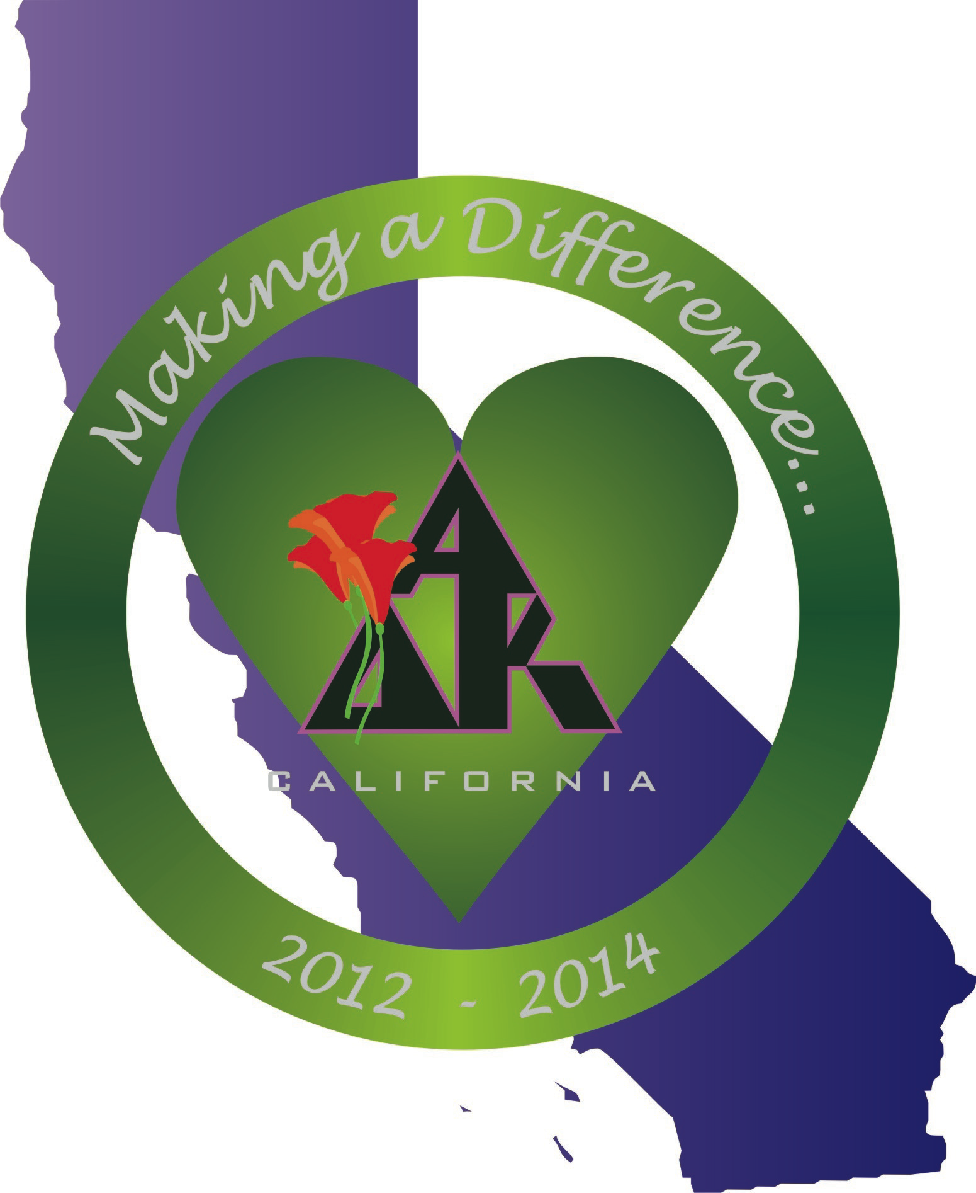
California Alpha Delta Kappa
Executive Board Meeting November 3rd, 2012
Holiday Inn Express, Delano, CA

1.0 Call to Order: Immediate Past President Susan Raffo called the meeting to order at 3:47 P.M.

2.0 Opening Thought: Rebecca read the opening thought “Wayfaring Song” by Henry van Dyke, which ended with “ With such a comrade, such a friend I feign would walk ‘til journey’s end, through summer sunshine and winter rain, then farewell, we shall meet again.”

3.0 Roll Call:
Members Present:
Susan Raffo Immediate Past President
Mary Ann Englehart President-elect
Kerry Hackman Vice-President
Diana Galvan Treasurer
Karen Kirby Recording Secretary
Monica Meade Historian/Sgt-at-Arms
Rebecca Sikes Chaplain
Absent
Mollie Acosta President
(due to illness)
Lynne Keating Corresponding Secretary
Guests
Kelly Meade Assisting the Historian

4.0 Approval of Agenda: Susan noted areas on the agenda where Lynne sent in comments.
MOTION: Mary Ann moved we approve the agenda as presented. Monica seconded the motion. Motion passed.

5.0 Approval of Minutes: Diana complimented the Recording Secretary, Karen Kirby, on the appearance of the minutes.
MOTION: Kerry moved we approve the minutes of October 6, 2012. Rebecca seconded. Motion passed.

6.0 Correspondence: Lynne sent the following report.
6.1 Sent: Thank you notes were sent to Janet Armstrong for her work on the state website, and Judy Garcia, President of Peralta Council for the wonderful Northern District Conference. In addition, Susan reported she sent a packet of evaluation forms from the Northern District Conference held in Pleasanton on October 6, to Judy Garcia, President of the Peralta Council.

6.2 Received: Shirley Kunze, Channel Islands recording secretary, sent an invitation inviting the members of the State Executive Board to the Marina District Conference on January 12, 2013. In addition, Mary Ann reported she received a thank you from Leadership Grant recipient Victoria Glines.

7.0 Budget/Expenses: Diana distributed the working budget dated 11/3/12.
7.1 Treasurer’s Report: Diana informed the Board of a problem with the alignment of the dates on the C-1 report and both the state and federal e-postcards. Everyone needs to align the dates on these items with the fiscal year June 1 to May 31. All chapter presidents need to sign and return a letter sent to them from International regarding this alignment. Not all E-1 postcards, both state and federal, have been submitted. This could result in the loss of tax-exempt status and/or a hefty fine. Diana asked the Board for suggestions on how to inform the California chapter presidents so this problem may be rectified. Mary Ann suggested the following:
1. Put printed directions on the website.
2. Send an eblast to all presidents.
3. Send information with liaisons to District meetings.
4. Send information by direct mail.
After discussion, it was decided Diana will compose another letter regarding the fiscal year alignment for chapter presidents to sign and return. Diana will also create a set of directions for completing the C-1 report. This will be mailed to all chapter presidents. Diana will contact International for a list of those who have already sent in the signed letter. An eblast will be sent to all treasurers so they may coordinate with chapter presidents. Liaisons will follow-up at council meetings. The reason for the urgency on this matter is the possibility of International A∆K having the tax-exempt status revoked. Some chapters have already lost their tax-exempt status and may not even know it.

7. 2 Budget and Balances: The Working Budget spreadsheet and the Account Balances sheet were distributed. Diana asked all Board members to review the Working Budget and make sure we all understand how it works and what it represents. The Account Balance sheet reflects the current balances in the CA A∆K bank accounts and investment accounts. The Wells Fargo accounts and balances are:

Checking Account $12,634.77
Reserve Account $45,844.08
Scholarship Account $13,586.67

Total Bank Accounts $72,065.52

Noel Leonard Foundation $39,761.66
Overall total $111,827.18

State Convention Account $10,629.22

Diana also distributed the most recent account activity spreadsheet for the Noel Leonard Leadership Memorial Fund. This report is sent quarterly. The next
report should come out in January. Susan asked Diana to make sure the quarterly report does come in January.

7.3 Reimbursements: All expense reimbursements and bills with receipts for the Valley District Conference and liaison expenses were circulated for review by the Board.

7.4 MOTION to pay bills: Diana moved to pay the bills submitted. Monica seconded. Motion passed.

7.5 Mary Ann will clarify the altruistic numbers and report them at the January meeting.

8.0 Unfinished Business:

8.1 Presidents’ Council Meeting Survey: Those who attended the Presidents’ Council Meeting at the California State Convention completed surveys. Kerry compiled the survey comments and read them to the Board. Her findings are:

SURVEY QUESTIONS:
* How to get new and younger members.
* How to get forms and fill them out on line.
* Being on the wheel of responsibility.
* Can we have personalized access/passwords for CA website.
* How about a 1/2 day training with historians. Historians could bring their own computers and work through it together.

SURVEY CONCERNS
* Some VPs are new and never attended a council meeting before.
* Computer and internet access
* Gamma Lambda - did not receive President's newsletter
* Eta - getting members to take on leadership roles - same old girls in charge
* Alpha Pi - need hard copies of all forms

8.2 Presidents’ Council Handbook Updates: Mary Ann has received corrections to the Handbook. The corrected copy will be maintained on the website. She would like all corrections emailed to her. She will send an updated Handbook to Janet to post periodically on the website. If an email is returned as undeliverable, check the online Handbook. Handbooks were mailed to Council and Chapter Presidents in the Marina and Southern Districts, and to State Committee Chairmen. Handbooks were distributed at the Northern and Valley District Conferences. They will be made available to Past State Presidents upon request.

8.3 Membership Report: Kerry reported CAA∆K has 53 chapters and one sustaining chapter for a total of 54 chapters. No members have been reinstated or transferred during this period. There are 29 sustaining members, 5 new members, and 6 members have resigned. Five members have gone to the Omega Chapter. Kerry has completed letters regarding dues for all sustaining members. Letters will also be sent to limited members. Pre-addressed, stamped envelopes will be included in the letters so members can return dues. All letters will be mailed Monday, November 5.

Gamma Nu will install the new chapter on April 15, 2013.

Kerry passed out the Member Action Plan (MAP) for 2012 – 2013. Everyone needs to review the plan. It will be put on the January agenda for further discussion. The plan includes membership goals with recruitment strategies, persons responsible, and a time frame for the strategies. Two new strategies have been added to the plan:

1.12 Work with Gamma Nu to help facilitate the new chapter in Orange County. All State Board members will be responsible. Target date is April, 2013.

2.11 Increase awareness of membership options: limited, life. All State Board Members are responsible. Time frame is ongoing.

8.4 2010 – 2012 State Board Officer Recommendations: Board members are asked to review recommendations from Recording Secretary, Corresponding Secretary, Historian, and State Committee members. We will discuss
recommendations at the January meeting.

Kerry will not be at the January meeting, so the Chaplain’s report and recommendations were reviewed. The recommendations were:

1. Have a two-year calendar ready and marked with the events for the biennium.
BOARD DISCUSSION: This is ongoing.
2. Begin looking for books that contain poems, sayings, stories that you may be able to use for your opening and closing thoughts. BOARD DISCUSSION: This is ongoing.
3. Create a book that you can keep your thoughts in. Many individuals will contact you for copies of your sayings at a later time. BOARD DISCUSSION: This is ongoing. The link “Chaplain’s Chatter” containing recommended readings has been created on the state website.
4. In planning for the Omega Service, start early. Find a chapter that is willing to help support you especially if the State Convention is not local. Decide on a theme and begin developing your service around the theme. BOARD DISCUSSION: This is ongoing.

8.4.1 Implications of Policy/Procedure and/or Officer Duties: There are no implications at this time.

8.5 California World Understanding Committee: This is tabled for the January meeting.

8.6 A∆K Shirts Update: Diana has located a vendor for the shirts that will not charge a set-up fee each time another order is placed. We decided to use that vendor. After discussion, it was decided each Board member would order a shirt to be worn at the Marina District Conference. We will take orders for shirts with payment instead of ordering the 75 shirts as originally planned. Cost will be determined after shipping costs are figured. Shirts will be offered for sale to chapter members and possibly at the International Convention. Diana will appoint a shirt chairman to collect orders and distribute shirts. Proceeds from the sale of the shirts will be divided equally among Scholarship and State Altruistic Project.

8.7 CA Logo Pins: Susan distributed information on pin designs. She described a new design based on Mollie’s logo. Kelly and Susan will work on the design and

present ideas at the January meeting. Final design, funding, and acquisition will be discussed then. Proceeds from the sale of the pins will be divided equally among Scholarship and State Altruistic Project.

9.0 New Business:

9.1 2014 State Convention Invitations: The Board received two letters of invitation from Inland Cities Council and Fresno-Clovis Council to hold the 2014 State Convention in their respective areas. Discussion ensued. It was noted the rotation schedule for the convention is in Policies and Procedures.

MOTION: Rebecca moved the 2014 State Convention be held in the Inland Cities Council area as per the Policies and Procedures: District Rotation for State Conventions. Monica seconded. Vote: 6 Yes, 1 No. Motion passed.

9.2 Policies and Procedures: Approval of Proposed Updated/Revisions:
Susan distributed a tracking sheet for the revisions made so far. Revisions were discussed. No action was taken. Drafts will be reviewed in January.
9.3 Liaison Reports: Diana reminded the Board they may submit expenses for only one liaison trip. The Board will revisit this issue at the next meeting. Karen reported on her visit to the Channel Islands Council meeting. She distributed officer training handouts at the meeting. Karen and Monica stated the Orange Coast Council meeting date will be November 10. Kerry reported on the Inland Cities Council meeting. She, Lynne, and Becky conducted officer trainings at the meeting. Mary Ann attended the Valley District Council meeting. Most of that meeting was devoted to their upcoming conference. No training was conducted because officer trainings were part of the conference agenda.

9.4 Evaluation of Valley District Conference: Mary Ann read excerpts from the attendees’ evaluations. Most ratings were a 4 or 5.
Lynne will be asked to send a thank you to the host council.

Monica will prepare a short summary of the conference for the November newsletter.

9.5 Marina District Conference: The Marina District Conference is January 12, 2013. Diana and Susan will fly in. The rest of the Board will drive. Mary Ann will send accommodation details later. The Conference has a full program, so we will not be doing officer trainings. Liaisons have conducted officer trainings at the Council meetings.

10.0 Technology:

10.1 State Website: If a Board member wants to put something on the State website, indicate when you want it posted. All pieces of the Officer Training Handouts must be sent to Susan so they may be posted on the website.

11.0 Announcements/From the floor:

The deadline for the President’s Newsletter is ASAP.

CA Mini Scholarship applications are due November 15. They go to Caroline Rising.

Chapters are urged to donate to Summer Search, the California State Altruistic Project. Checks go directly to Diana Galvan. Only money for the state project is sent to Diana. Chapter altruistic projects are handled and funded by individual chapters.

12.0 Closing Thought: Rebecca read “A Road Not Taken” by Robert Frost, which ends with “I took the road less traveled by and that has made all the difference.”
13.0 Adjournment: The next Board meeting will be January 9 - 11 during the Marina District Council Conference.

The meeting was adjourned at 7:10 P.M.

Submitted by,
Karen Kirby
Recording Secretary
California State Executive Board

