California Alpha Delta Kappa
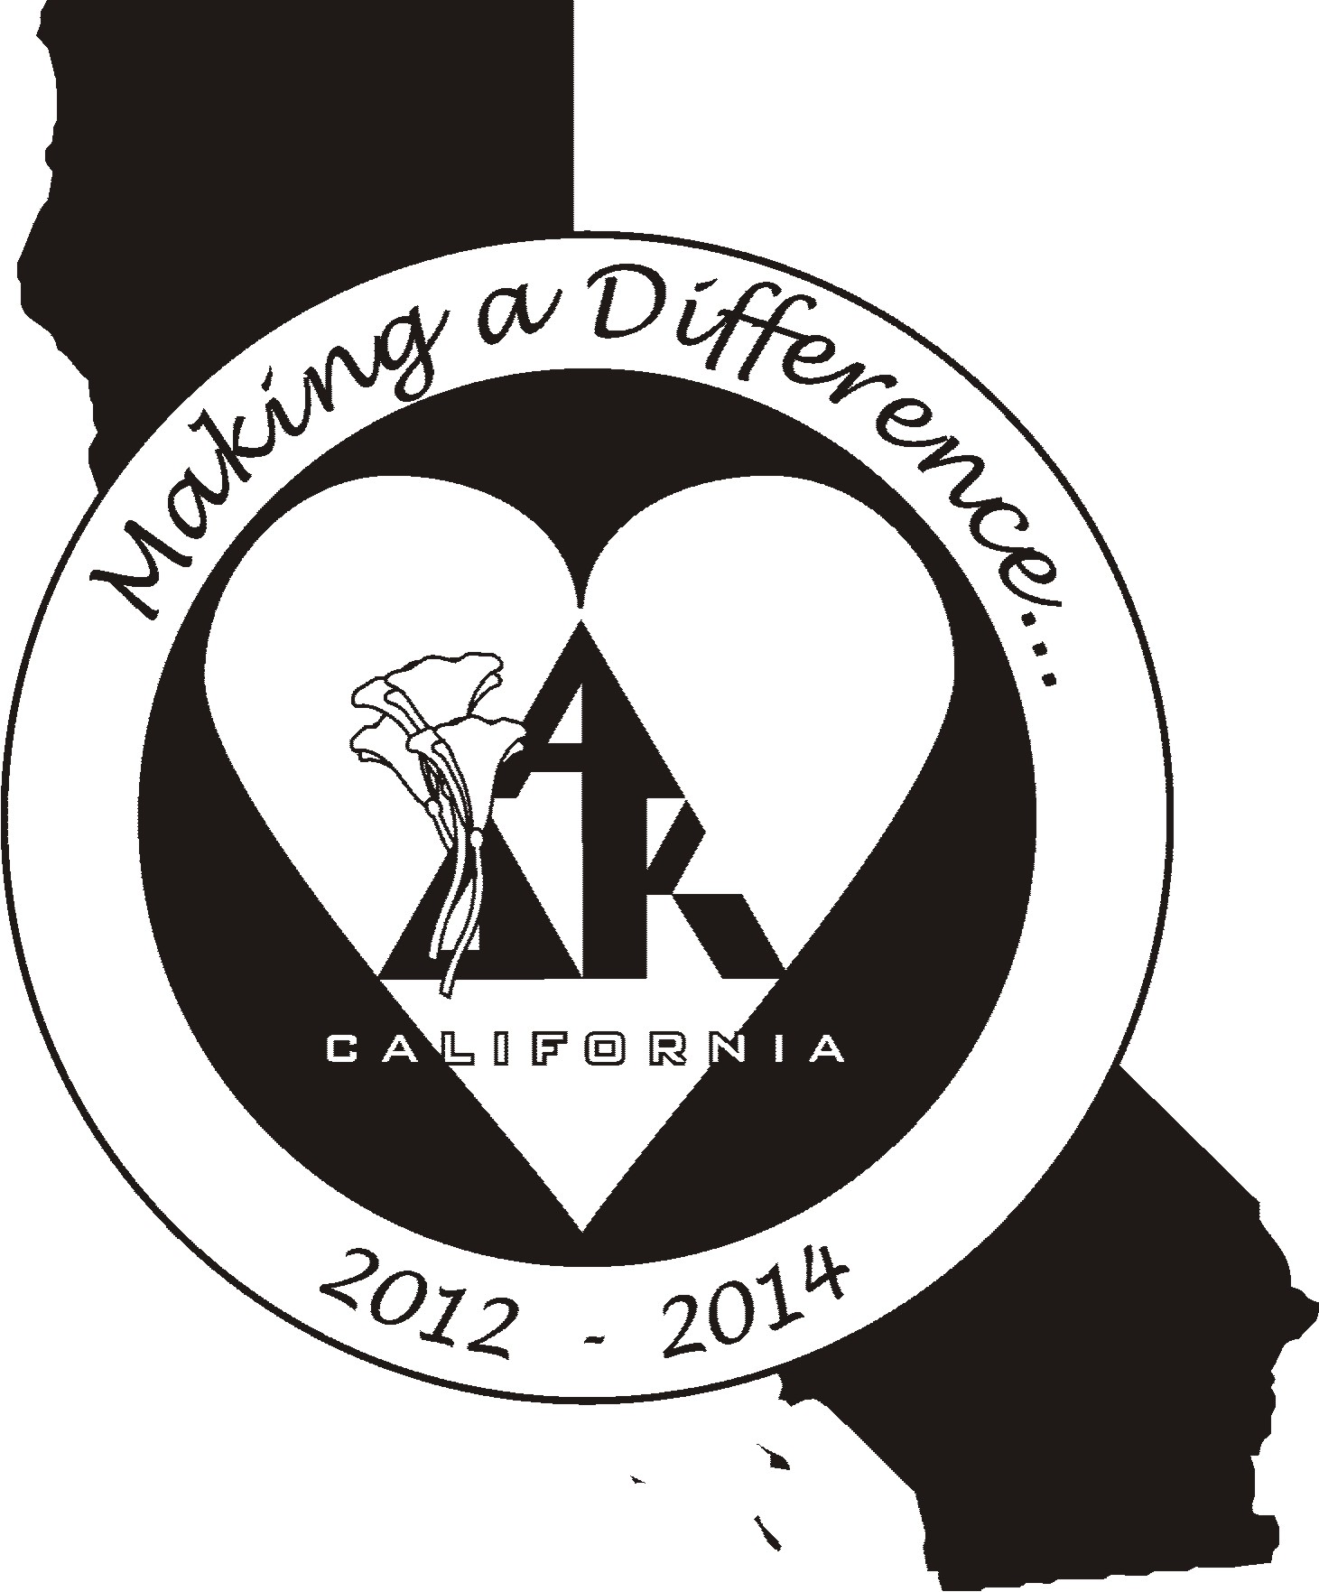
Post-Convention Executive Board Meeting
Solano Room, Embassy Suites
Burlingame, California
May 6. 2012

1.0 Call to Order President Mollie Acosta called the meeting to order at 11:40 A.M.

2.0 Roll Call Members present:
Mollie Acosta, Xi President
Susan Raffo, Beta Rho Immediate Past President
Mary Ann Englehart, Xi President-elect
Kerry Hackman, Gamma Sigma Vice-President, Membership
Diana Galvan, Beta Eta Treasurer
Karen Kirby, Gamma Mu Recording Secretary
Lynne Keating, Gamma Eta Corresponding Secretary
Monica Meade, Zeta Historian/Sgt-at-Arms
Barbara Stanfield, New Mexico International Representative
Absent: Becky Sikes, Alpha Pi Chaplain

3.0 Approval of Agenda Susan Raffo moved to approve the agenda. Mary Ann Englehart seconded the motion. The agenda was approved as presented.

4.0 Opening Thought Kerry Hackman shared “Greeting the Day” by Chaplain Becky Sykes in which we were encouraged to “Move forward – You will make a difference”.

5.0 Correspondence There was no correspondence to report.

6.0 Treasurer’s Report
6.1 Diana Galvan distributed report forms for expense receipts and detailed instructions regarding reimbursements. Mary Ann Englehart will make all registration and accommodation reservations for the Board for District Conferences. Each individual must make her own transportation arrangements. Susan Raffo will investigate the feasibility of changing the current mileage rate and report to the Board in August.

6.2 Budget money is available for the President, President- elect, Past President, and Treasurer to attend the Northwest/Southwest Regional Conference. The rest of the Board shares a budget line-item for the conference.

6.3 Discussion items: Carole Taylor expects a differential after all receipts are in. This will be forwarded to the new biennium. CA A∆K saved $1,000 by sending the newsletter electronically. Special thanks goes to Barbara Stanfield who made a donation to Summer Search. Questions arose regarding specific days/hotel stays that will be reimbursed for NW/SW Region Conference. Susan Raffo will check to see if there is a parallel International policy.

6.4 Barbara Stanfield congratulated CAA∆K on the success of the conference. She recognized President Mollie Acosta’s outstanding leadership which will lead to a great new biennium. Barbara invited everyone to attend the NW/SW Regional Conference. She commended CAA∆K for the state altruistic efforts, grants to first-timers, and other programs that encourage growth and strengthen the organization. She congratulated CAA∆K as we separately and together work to make a difference.

7.0 New Business
7.1 President Mollie Acosta reviewed the Calendar of Dates for the new biennium.
7.2 The members of the Candidates Qualifications Committee were reviewed. Mary Ann Englehart moved to select Virginia Berry, Beta Phi, to chair the committee. Kerry Hackman seconded the motion. Discussion followed. Motion was carried.
7.3 The Presidents’ Council Survey was tabled until August.
7.4 NW/SW Conference was discussed earlier.
7.5 Leadership Training will be held in Fresno August 17 – 19, 2012. This will also be a Special Board meeting.

8.0 From the Floor The Board discussed the posting of the Convention minutes on the website. Lynne Keating will be asked to send an e-blast to members when the minutes are posted. Mollie will send a letter to the Board’s principals and superintendents informing them of the new officers on the CAA∆K State Board after Mollie requests the addresses from each Board member via e-mail.

9.0 Closing Thought Kerry Hackman read closing thoughts composed by Chaplain Becky Sikes which ended with, “Embrace your strength, the encouragement of sisters, and the ‘fierce’ reality that you make a difference.”

10.0 Adjournment Mollie adjourned the meeting at 1:45 P.M..

Karen Kirby
California Alpha Delta Kappa Recording Secretary

