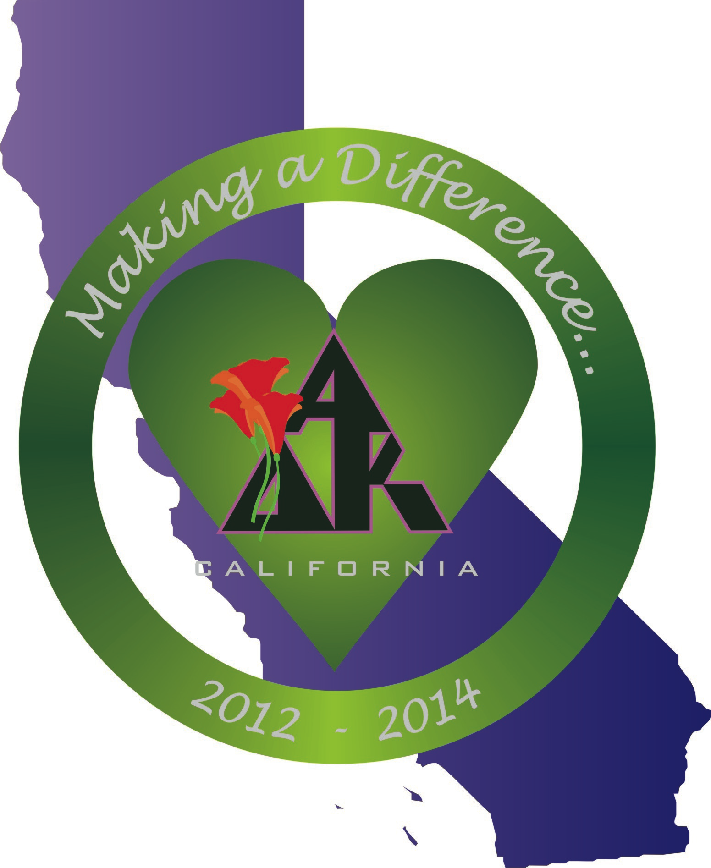
California Alpha Delta Kappa
Executive Board Meeting
January 12, 2013
Westlake Hyatt Regency. Westlake, California

1.0 Call to Order: California State President Mollie Acosta called the meeting to order at 2:07 P.M.

2.0 Opening Thought: Rebecca read the opening thought “Is it Recession or Depression?” from Simple Abundance by Sarah Ban Breathnach: It’s a recession when your neighbor loses his job, and it’s a depression when you lose your own – Harry Truman. It’s easy to be pessimistic about tomorrow when today seems so bleak. It’s time to put thoughts of lack behind us. Optimism, like the happiness habit, can be learned. Let the past go. A simply abundant world awaits.

3.0 Roll Call:
Members Present:
Mollie Acosta President
Susan Raffo Immediate Past President
Mary Ann Englehart President-elect
Diana Galvan Treasurer
Karen Kirby Recording Secretary
Lynne Keating Corresponding Secretary
Monica Meade Historian/Sgt-at-Arms
Rebecca Sikes Chaplain
Absent
Kerry Hackman Vice-President

Guests
Kelly Meade Assisting the Historian

4.0 Approval of Agenda:
MOTION: Mary Ann moved we approve the agenda as amended, with 9.8 International Convention added. Monica seconded the motion. Motion passed.

5.0 Approval of Minutes:.
MOTION: Mary Ann moved we approve the minutes of November 3, 2012 as corrected. Diana seconded. Motion passed. Mollie directed Karen to distribute corrected minutes to Executive Board members.

6.0 Correspondence: Lynne read the text of all sent and received correspondence.
6.1 Sent:
* Mollie sent an email regarding a meeting to discuss former Gamma Rho chapter to Lei’ala Montoya, former Gamma Rho member.

* Lynne sent letters to Fresno-Clovis Council Co-Presidents Christel Biasell and Maureen Chase, both of Xi chapter, declining their invitation to host the 2014 State Convention.
* Lynne sent a letter to Inland Cities Council President Judi Nowlin, Tau, accepting the invitation to host the 2014 State Convention.
* Lynne sent a note to Donna Ray, Beta Zeta, informing her of a contribution to the California Alpha Delta Kappa Scholarship fund made by Judy and Hank Welch in memory of her late husband, Dave.
* Lynne sent a thank you note to Kathy Layman, Bakersfield-Delano Council President, Chi, for hosting the Valley District Conference.
* Susan sent a thank you note to Rosalina Rivera, Superintendent of Delano School District, Chi, for her assistance at the Valley District Conference.
* Mollie sent an email to all California Alpha Delta Kappa members regarding the Connecticut School tragedy.
* Mollie sent an email to Irene Veillette, Connecticut Alpha Delta Kappa State President, offering sympathy and support following the Connecticut school tragedy.

6.2 Received:
* An email was received from Lei’ala Montoya, former Gamma Rho member,
which gave information about the February, 2013, visit regarding the lapsed chapter Gamma Rho.
* An email was received from Irene Veillette, Connecticut Alpha Delta Kappa State President in which she thanked Mollie for her support and gave information for donations to Sandy Hook Elementary School
* A letter was received from Mitzi Holmes, Alpha Delta Kappa International President which sent greetings for the new year and gave information regarding the membership campaign, a visit to St. Jude’s, Project H.O.P.E, and the International Convention in July, 2013.

7.0 Budget/Expenses: Diana distributed the working budget dated 1/9/13.
7.1 Treasurer’s Report: Diana sent a follow-up letter regarding the fiscal year alignment requirement to all chapters. In the letter, she described what to do to align with the fiscal year, why it is important to do so, what the consequences are if a chapter does not align. Diana has communicated with those chapters who have not sent in the signed letter stating e-postcards were sent. Two chapters in the Marina District had not sent in letters. Diana discussed the issue with
members of those two chapters at today’s Marina District Conference. They assured her the issue will be taken care of. She will monitor and follow up with chapters still not complying in March.

7. 2 Budget and Balances: The Working Budget spreadsheet and the Account Balances sheet were distributed. The Account Balance sheet reflects the current balances in the CA A∆K bank accounts and investment accounts. The accounts look much healthier now that dues are coming in. The Dues line item was originally calculated based on 1,450 dues paying members, which is not accurate due to a number of California Life Members who do not pay California dues. Diana suggested we calculate this line item on dues-paying members as of 2012. There may be a short-fall because income from dues may be less than expected. Mollie asked that as we build the next budget we take this into account and build the budget on only dues-paying.

The Wells Fargo accounts and balances are:

Checking Account $20,829.24
Reserve Account $45,862.61
Scholarship Account $13,590.09

Total Bank Accounts $80,281.94

Noel Leonard Foundation $39,761.66
Overall total $120,043.60

State Convention Account $10,601.63

7.3 Reimbursements: All expense reimbursements and bills with receipts for the Marina District Conference were circulated for review by the Board.

7.3.1 Hawaii sisters are very interested in starting a new chapter of former Gamma Rho sisters and have asked State Board members to attend a new chapter development meeting in Indio on February 16, 2013. The Board discussed reimbursement for travel expenses for those Board members who attend the meeting. The budget has a line item for Membership and Chapter Development with $500.00 allocated to the line item. This could be used to reimburse travel expenses for Board members who attend the meeting. Susan, Lynne, and Mary Ann will attend as a fact-finding committee representing the CA State Board.

MOTION: Diana moved that Lynne Keating, Mary Ann Englehart, and Susan Raffo be reimbursed for travel expenses to attend the February 16, 2013 fact-finding meeting in Indio, California, with former Gamma Rho sisters to explore possible development of a new chapter. Expenses should be charged to the New Chapter Development line item in the budget. Lynne seconded. Motion passed.

The Board discussed travel expenses reimbursement for Board Members to attend the new chapter installation in Fullerton on March 16, 2013. The State President is required to attend new chapter installations.

MOTION: Lynne moved that the President, President-Elect, and Immediate Past President be reimbursed for travel expenses to Fullerton/La Habra, California, for the March 16 charter of the new Orange County chapter. Expenses should be charged to the New Chapter Development line item in the budget. Susan seconded. Motion passed.

7.4 MOTION to pay bills: Mary Ann moved to pay the bills submitted. Becky seconded. Motion passed.

8.0 Unfinished Business:
8.1 Presidents’ Council Handbook Updates: Mary Ann received handbook updates at the Marina District Conference.

8.1.1 Council Role/Duties: Liaisons were asked to read the Council role and duties, found in the President's Council Handbook, when giving the liaison report at the next Council meeting.

8.1.1.a Historian Training: Mollie will put an item in the next newsletter regarding help for chapter historians as they create their pages for the online scrapbook. Anyone needing help should contact their liaison. It was suggested tutors be enlisted to assist. Former historians that were successful in creating pages for the past biennium could be
tapped as tutors also. Diana suggested Kelly and Monica establish an historians’ database to communicate with all chapter historians. Current historian information may be found in the Presidents’ Council Handbook.

8.2 Membership Report: Kerry submitted her report to be read at the meeting in her absence. She reported CAA∆K has 53 chapters and one sustaining chapter for a total of 54 chapters. No members have been reinstated or transferred during this period. There are 30 sustaining members. There are no new members and no resignations since the last meeting. Six members have gone to the Omega Chapter since May, 2012. Kerry has sent letters to all sustaining/limited members who were required to pay in November requesting dues payment. Letters were also sent to members who did not pay dues wishing them a happy holiday season and letting them know we were thinking of them and were here if they needed anything. Diana and Kerry are working together to ensure all sustaining/limited members have paid dues. Only 3 are outstanding. Kerry is sending a second letter to them.

The California Membership Report was sent to Mollie and the Southwest Region Membership Consultant. An eblast was sent from Carole Taylor to all chapter presidents to be forwarded to chapter membership chairs wishing a happy holiday season and asking for return emails regarding chapter triumphs and concerns. Only one response has been received as of yet.

The Orange County prospective chapter installation is schedules for March 15, 2013.
The meeting regarding reviving membership in the Palm Springs area is still scheduled for February. Barbara Stanfield will be attending.

Diana suggested the Board offer a reward/incentive for increased membership, perhaps a $100.00 check to the chapter that has the most new members. The check would be used at the discretion of the chapter. Mary Ann suggested the incentive be offered in each District. This will be placed on the agenda of the next meeting.

8.3 2010 – 2012 State Board Officer Recommendations: in preparation for this meeting, Board members were asked to review recommendations in the 2012 State Convention minutes submitted by the Recording Secretary, Corresponding Secretary, Historian, and State Committee members. The recommendations from State Board Officers are as follows:

8.3.1 California State Recording Secretary Marilyn Anania:
1. Incoming State Recording Secretary be co-notetaker of Convention minutes and assembling of biennium convention booklet. BOARD DISCUSSION: When possible, efforts will be made to include the incoming State Recording Secretary.
2. Minutes to mainly reflect basic numbers for treasury, statewide membership, and motions. BOARD DISCUSSION: This will be done.
3. All manuals to be uploaded online and maintained by the Webmaster. BOARD DISCUSSION: Manuals will be posted online. This is a work in progress.
4. Posting of simplified minutes on A∆K California Website edited by President. BOARD DISCUSSION: This is currently in progress. Full and complete minutes are being posted on the California Website.

8.3.2 California State Corresponding Secretary Robin Burns:
1. Continue sending the President’s newsletter via email. BOARD DISCUSSION: This is currently being done by the California State Communications Chairperson.
2. Keep database current, especially e-mail addresses. BOARD DISCUSSION: This is being done for chapter officers. This will be expanded to include all members.

8.3.3 California State Historian/Sergeant-At-Arms Diana Galvan:
1. Continue use of online scrapbooking tools to create and maintain CA archives for the biennium. BOARD DISCUSSION: This is being done.
2. Maintain detailed instructions for use of archiving tools on CA website for
chapter and council historians. BOARD DISCUSSION: This is being done.
3. Pursue online archive storage possibilities for historical paraphernalia related to A∆K. BOARD DISCUSSION: This is a work in progress. Possibilities are being explored to create an archives link on the website so chapters may have an archive site. Maintaining an archive link may be an additional duty for the CA historian.

8.3.4 Implications of Policy/Procedure and/or Officer Duties: Susan will review Policies and Procedures to investigate how Corresponding Secretary can assist the Sergeant-At-Arms at the State Convention.

8.4 Recommendations from California State Chairmen The recommendations from California State Chairmen are as follows:

8.4.1 California State Scholarship Chairman Carolyn Rising:
1. Move the four district names and check off boxes to the top of the scholarship form. BOARD DISCUSSION: The Board will get further information and revise the form as needed.
2. Update all forms with the new scholarship chairperson’s snail mail and email addresses soon. BOARD DISCUSSION: This is being done.
3. Create some sort of accountability so that we know the funds granted are used as stated – copies of receipts? Evaluation forms? We do not want the application process and accountability component to be so burdensome as to limit applications. BOARD DISCUSSION: Recipients might be asked to present at a District Conference how the grant funds are being used. This could be part of the obligations in receiving the grant. The Board will look into revising and expanding the obligations section to reflect reporting by the recipient.

8.4.2 California Altruistic Chairperson, Northern California, Gloria Medina:
1. Using the Presidents’ Council Directory, obtain from each chapter president the name and contact information of the chapter’s Altruistic Chairperson. BOARD DISCUSSION: This is being done.
2. If chapter contact does not have an email, send a hard copy of the reporting form. If this is done early, it minimizes the need for last minute phone calls to meet deadlines. BOARD DISCUSSION: This should be listed in the chairperson’s duties.
3. Present a workshop at the District Council on reporting forms. BOARD DISCUSSION: The Board will explore this further.
4. Utilize the communication network provided by Carole Taylor. BOARD DISCUSSION: This is being done.

8.4.3 California Altruistic Chairperson, Southern California, Monica Meade:
1. The next Altruistic Chairperson should send a reminder to chapters early giving them the dates that their Altruistic Reports are due. BOARD DISCUSSION: This should be publicized in January. Members will be urged to utilize the A∆K Odd Year/Even Year calendar of deadlines which may be found on the International website.

The remaining Chairperson reports were tabled for the next meeting starting with the By Laws Chairperson.

8.5 California World Understanding Committee: International has asked states to consider creating a World Understanding Committee to publicize the current International World Understanding project. Discussion followed as to who would be responsible to carry out this communication, pursue avenues of communication, and coordinate with the Southwest World Understanding Chairman. Diana
suggested a California World Understanding Chairman be established with corresponding duties written into the Policies and Procedures. This would be a position appointed by the CA State President as provided for in Policies and Procedures. Mollie will establish the California World Understanding Committee and search for a chairman. She will present her results at the next meeting. It was suggested that the creation of this committee be an article in the Newsletter and include asking if anyone would be interested in developing this new state committee.

8.6 A∆K Shirts Update: The shirts are completed and will be mailed to Board members who will evaluate them. Evaluations will determine if more will be ordered. The decision to proceed with ordering/selling will be made at the Southern District Conference in March.

8.7 CA Logo Pins: Kelly and Susan displayed four possible designs for the new pins. Additional designs will be created using different A∆K color combinations of purple, green, and gold. Additional designs will be sent to all Board members. A design will be chosen at the March meeting. The Board will recognize Ophelia, who has been the graphic designer on this, when the pins are finalized.

9.0 New Business:
9.1 2013 International Membership Seminar Input: International has requested
input for the Membership Seminar. Kerry sent the following ideas regarding the seminar:

“From my perspective, I would like to see what other states/chapters are presenting to their chapters about membership; how to get new members, how to encourage the taking on of leadership positions, how to encourage more participation and greater numbers of members showing to meetings; program opportunities they offer. I would also like to see what the other VP of Memberships do in their states, to see if there are things I can incorporate, do more of, etc.”

Other Board members agreed and offered several other items such as states with similar populations and geographic similarities.

9.2 Disaster Relief Guidelines/Committee: This was tabled for the March meeting.

9.3 2014 State Convention: Mollie is working on obtaining chairpersons for the convention committees. She will report on her progress in March.

9.4 Policies and Procedures: Susan distributed revised drafts of the following Policies and Procedures pages:
P. A-1 and A-2: With no objections from the Board, these pages were approved.

P. A-3a and P. A-3b: With no objections from the Board, these pages were approved.

P. A-4: #1 was revised to add ‘dues paying’; #2 will be written by Susan and Diana to align more with a timeline; #3 stays as presented.

P. A-4, A-5. A-6, A-7: Discussion: The possibility of all Policies and Procedures involving dues and expenses may be placed in the finance section. Susan and Diana will review and revise
this section. The finance section may be aligned with the current budget format and line item categories.

P. A-8: Will stand as is with the minor correction of changing ‘is’ to ‘are’.

The remainder of the revised sections will be reviewed in March.

9.5 Liaison Reports: Mollie has sent the new report to all liaisons to be shared at the next Council meeting.

9.6 Evaluation of Valley District Conference: Board members reviewed conference evaluation forms.

Lynne will write a thank you to Barbara Murray and host Channel Islands Council.

Monica will prepare a short summary of the conference for the next newsletter.

Mary Ann will give Marina District Conference evaluation forms to Barbara Murray, Channel Islands Council President, Alpha Iota.

9.7 Southern District Conference: The Southern District Conference is March 9, 2013, in San Diego. Mary Ann will arrange lodging. Susan and Diana will fly to San Diego. The rest of the Board will travel by car. Fraternity Education will be similar to the one conducted at the Marina District Conference.

9.8 International Convention: : All Board members are planning to attend at this time with the exception of Rebecca Sikes. At the March meeting, we will review the section in Policies and Procedures for International Convention reimbursement.

10.0 Technology State Website: There is no new information. Items to be posted on the website need to be described in detail and include clear instructions where you want the posting located. Write the text as you wish it to appear on the site. Send items to Susan who will forward it to Janet Armstrong, Web Master, for posting.

11.0 Announcements/From the floor: There were no announcements.

12.0 Closing Thought: Rebecca read “He Does not Come Alone” author unknown, which begins with “When a child walks into your classroom, he does not come alone” and describes all that he brings with him. We have the power to make his future bright. The selection ended with “When he leaves you at the end of the day, how will you send him home?”

13.0 Adjournment: The next Board meeting will be March 8 – 10, 2013, during the Southern District Conference in San Diego.

The meeting was adjourned at 6:18 P.M.

Submitted by,
Karen Kirby
Recording Secretary
California State Executive Board

